User Guide:
Commercial Lead to Lease

Version History
Version | Description of Change | Author | Date
0.1 | First Draft | Jacob Smycz | 17/03/2025
2.0 | Updates from Tenancy Review project | Nikki Papenfus | 07/08/2025

Table of Contents
1. Overview 3
2. How to Update Marketing Rent 4
2.1 Creating a new Product 5
3. Receiving and Recording Offers 9
3.1 Creating a new Account and new Contacts 9
3.2 Create a Commercial Opportunity 11
3.3 Create a Commercial Offer 14
3.4 Update Offered Price 18
3.5 Copying an Offer 19
4. Asset Management and Investment Committee Approval 21
4.1 Asset Management Approval Process 21
5. Progressing or Closing the Commercial Opportunity 26
5.1 Capturing Comments & Delays 26
5.2 Closing a Rejected Opportunity 28
6. Initial Integration to Qube 30

Overview
The Commercial Lead to Lease process takes place from the time that a Commercial unit is available to let until all activities required to capture and track the progress of the let is completed. These activities include:
- Adding and updating marketing rents
- Recieiving offers from commercial agents
- Capturing multiple offers throughout the negotiation process
- Saving draft lease documents
- Adding the tenant details to Qube
- Saving signed lease documents
- Tracking fit out
As soon as an offer is made for a commercial unit, a new Account should be created in Salesforce for the tenant (if it does not already exist) as well as a new Commercial Opportunity.
- Each Commercial Opportunity has a number of stages that the process will progress through.
- Each stage signifies where the Opportunity is up to, and some stages can only be progressed to after an Approval.
- Each Commercial Opportunity needs to have an Offer created to capture the initial offer put forward by the agent.
- Any subsequent offers with different terms should captured by creating a new Offer with the new terms.

How to Update Marketing Rent
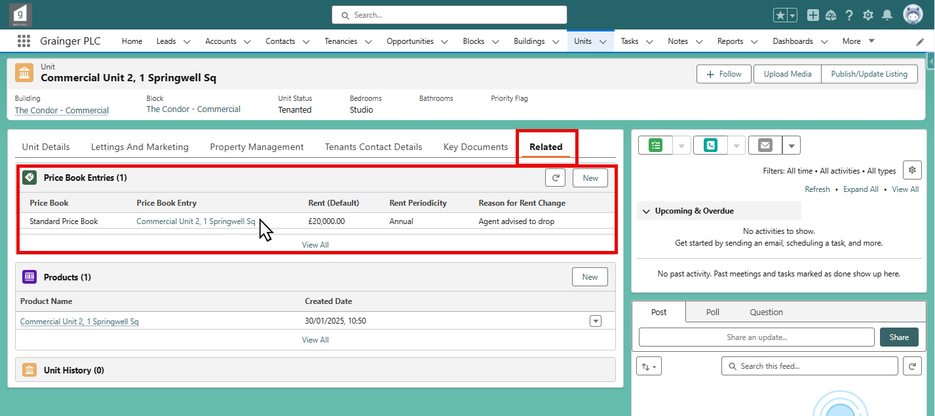
Updating the Marketing Rent for a Unit is done from the Unit’s Price Book Entry.

To update the Marketing Price, open the Standard Price Book Price Book Entry
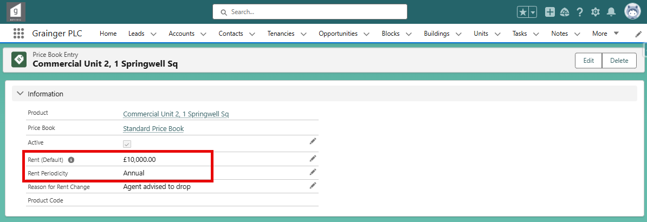
Input the price for the unit in the Rent (Default) field
Ensure that Rent Periodicity is ‘Annual’ – all Commercial Price Book Entries need to ‘Annual’.
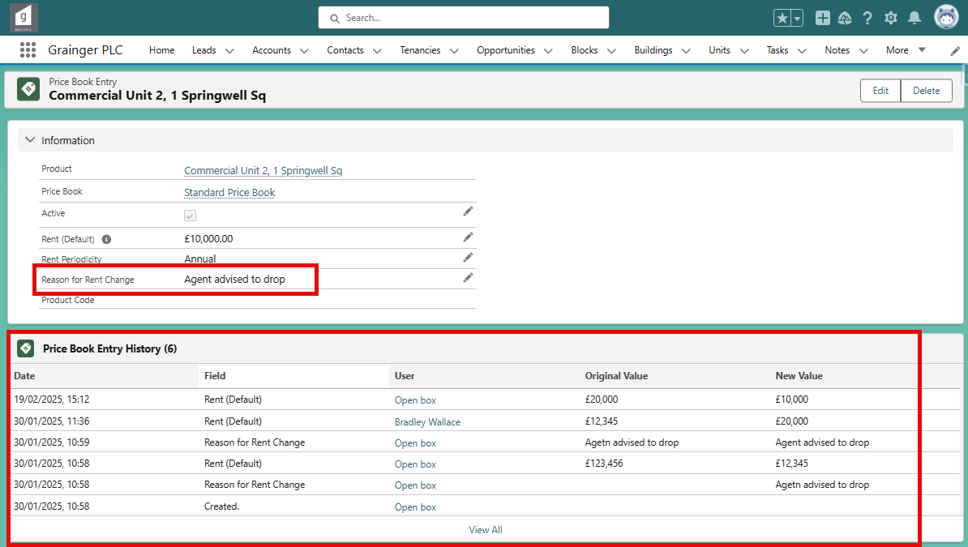
If there is a price change, capture the reason in Reason for Rent Change. Any changes made to a price book entry will be tracked and the history can be seen at the bottom of the page.

Creating a new Product
When a new Commercial Unit is added to Salesforce (a new Unit would have been added to Qube which creates the Unit in Salesforce), a new Product will need to be created and the Standard Price Book Entry will need to be updated.
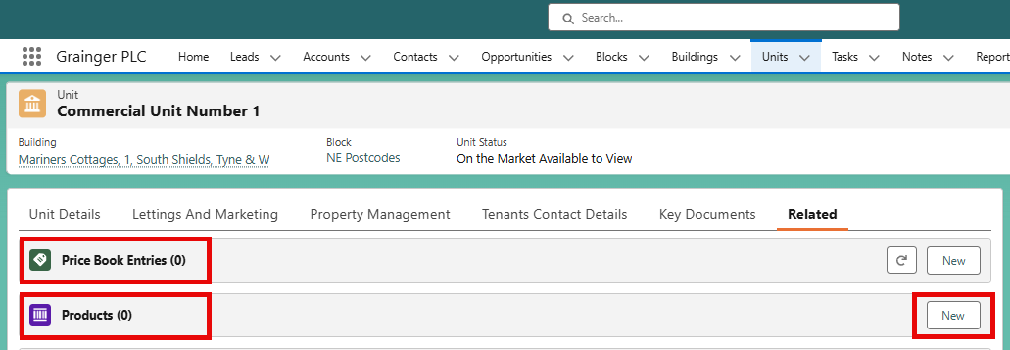
A Product first needs to be created. Grainger’s naming convention is to name the product the same as the Unit. In this case it will be “Commercial Unit Number 1”. Click on the “New” button in the Products section. The below screen will then pop up.
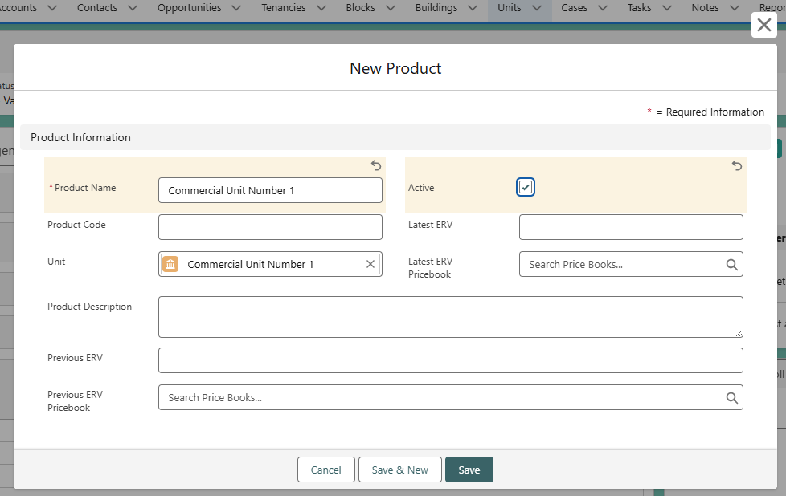
Enter the Product Name and mark it as Active. Then click save.
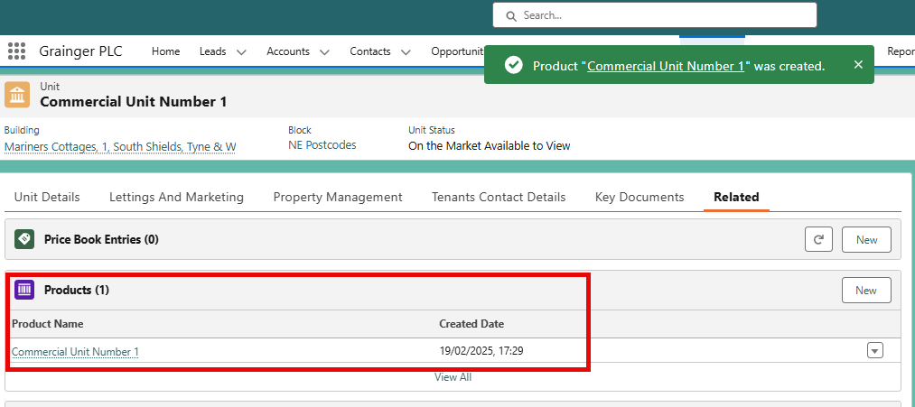
Now that a Product exists for the unit, the standard Price Book Entry can be updated.
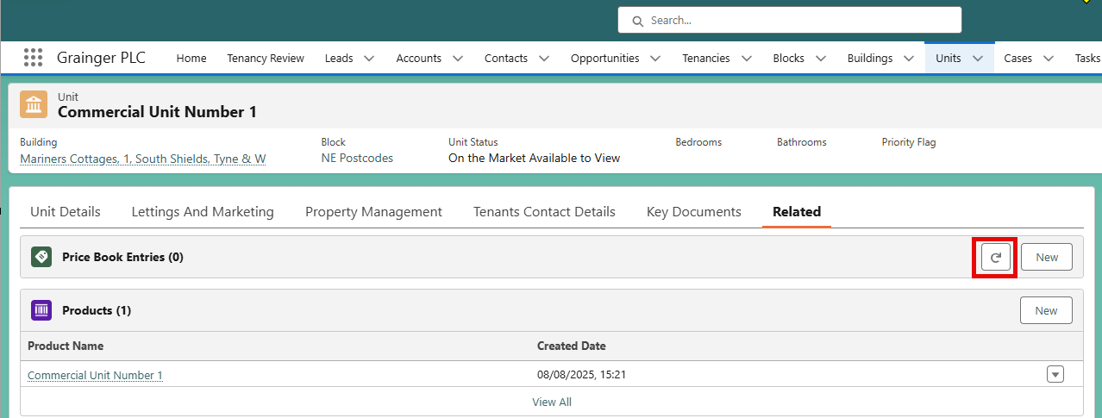
Click on the “Refresh” button in the Price Book Entries section.
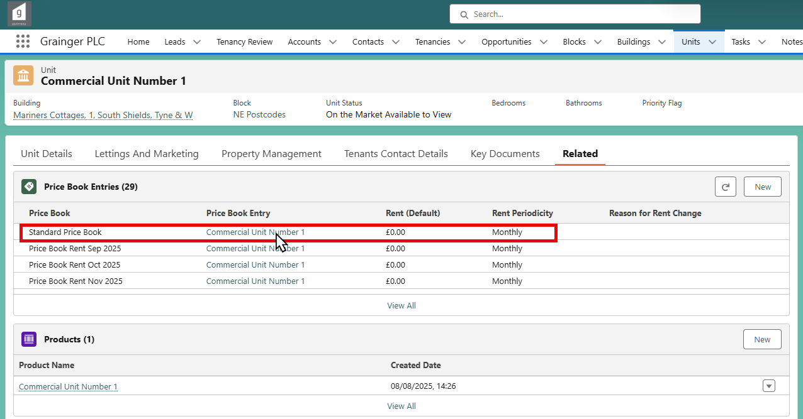
Then select the price book entry for the Standard Price Book.
The below screen will display:

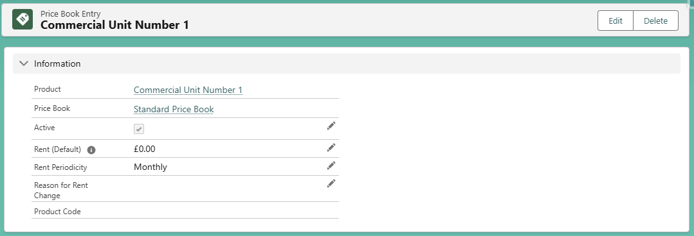
Update the Rent (Default) amount and update the Rent Periodicity to ‘Annual’. Ensure the ‘Active’ box is ticked.

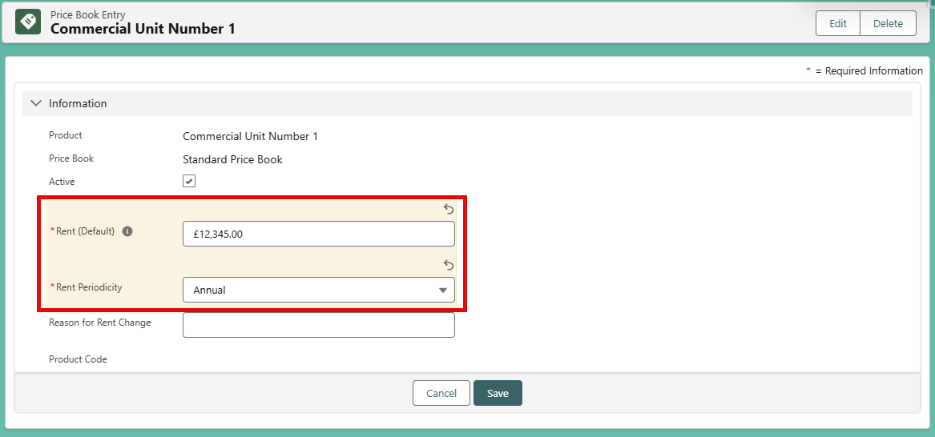

There is now a Product and Price Book Entry for this Unit.
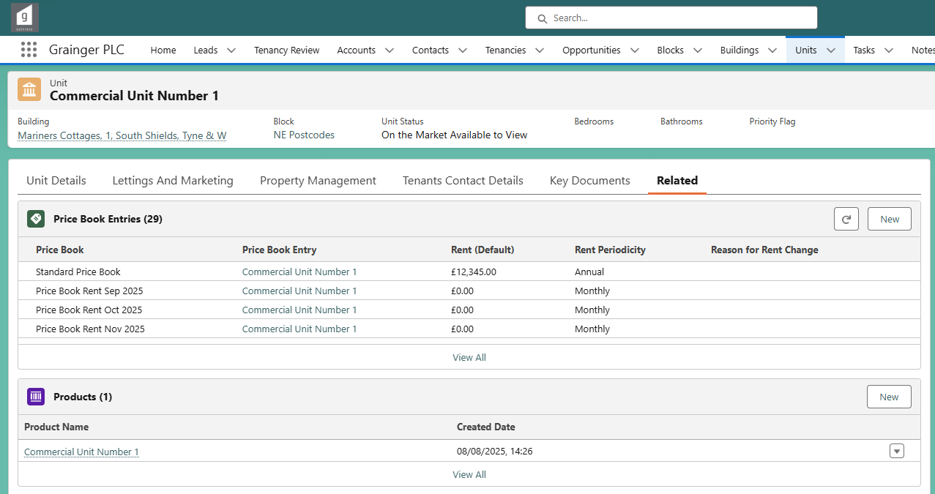

Receiving and Recording Offers

Creating a new Account and new Contacts
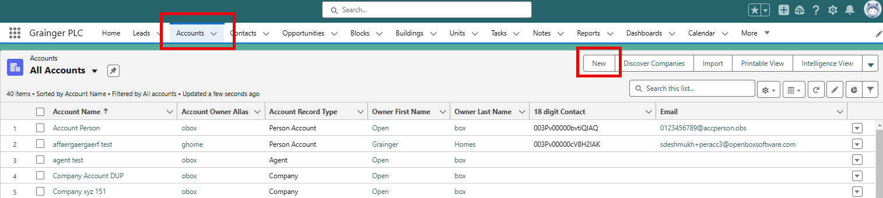
To create a new account, click on Accounts tab on the top ribbon and then click on the button “New”. The below screen will then be displayed. For the Commercial Lead to Lease Process, ‘Company B2B’ or ‘Person Account’ are the record types that must be selected.
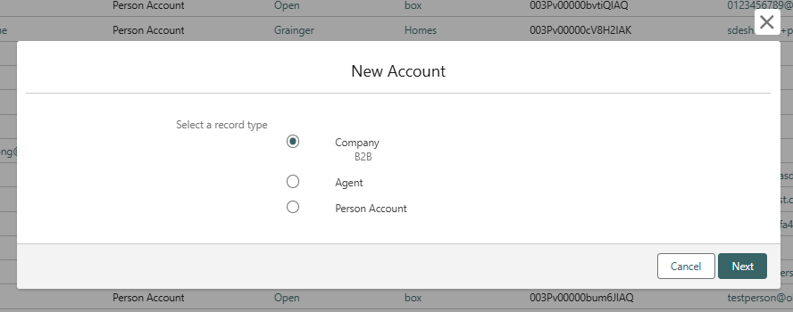

Click Next and then input the relevant Account Details. This includes:
- Account Name
- Company Number
- Company Email
- Phone Number
Then click Save.

To create any Contacts, i.e. people that are related to this company which could be owners, tenants, points of contact etc, navigate to the Related Tab on the Account and then click “New” in the Contacts section.
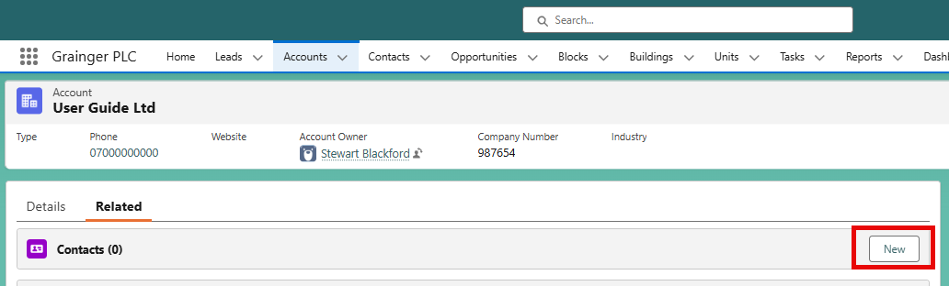
The below screen will then display and the details of the person can be entered.
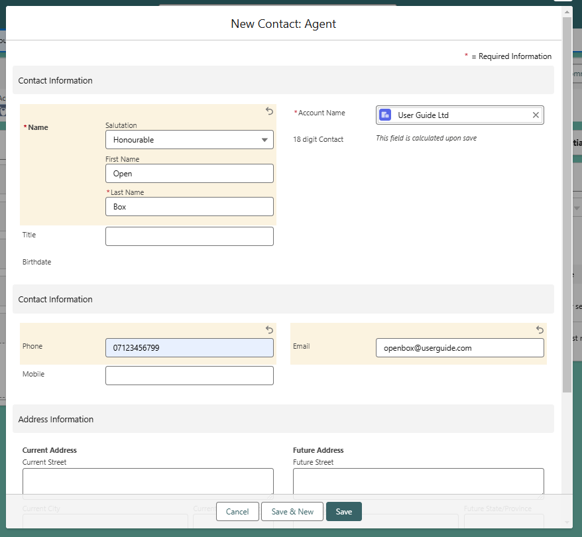
Clicking Save will then create this Contact and their details will be shown on the Account under the Contacts section on the related tab.
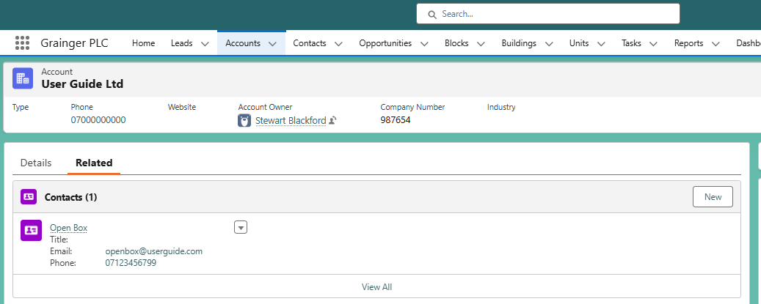

Create a Commercial Opportunity
To create a new Commercial Opportunity, always use the button on the company or person account. This ensures that the relevant Contact to represent the Account is created and can be passed to Qube later on in the process.
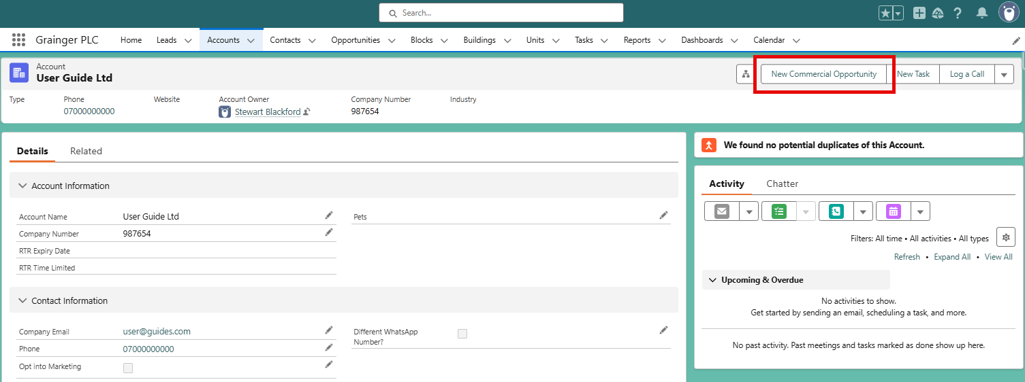
After clicking the “New Commercial Opportunity” button, the below screen will be displayed. Enter here the details of the Agents, both Local and National, as well as any Contacts from those agencies.
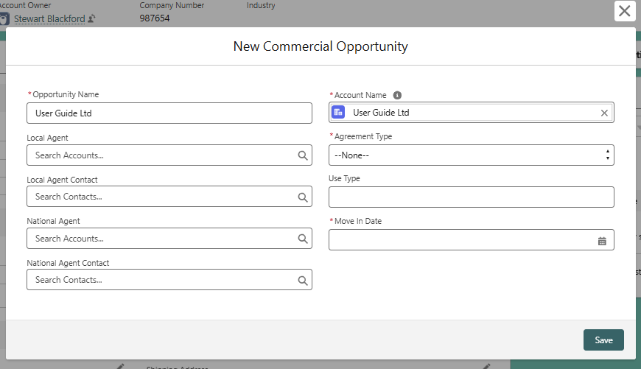
Select the correct Agreement Type from the picklist; either Commercial Lease or Commercial Licence.
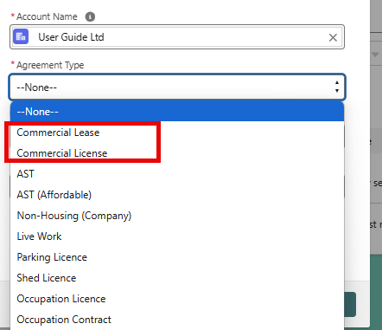
Finally, enter the Move In Date. This can be an estimate as it is not always known right away when the tenant will take possession of the unit.
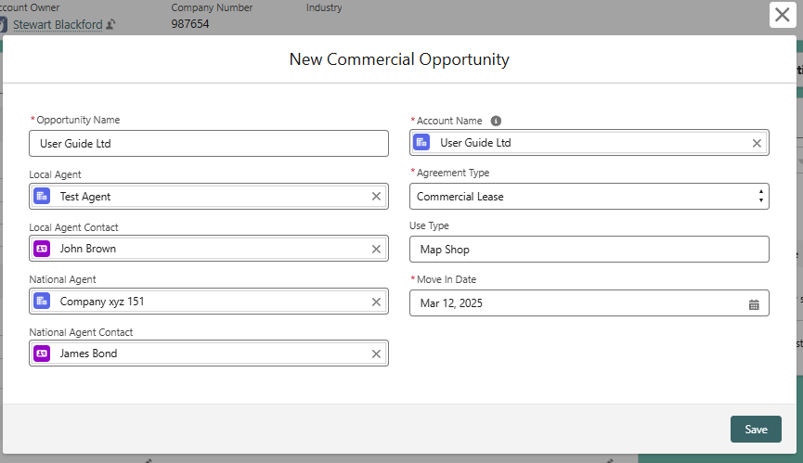
After clicking Save, a new opportunity will be created which will be visible from the Related Tab on the Account.
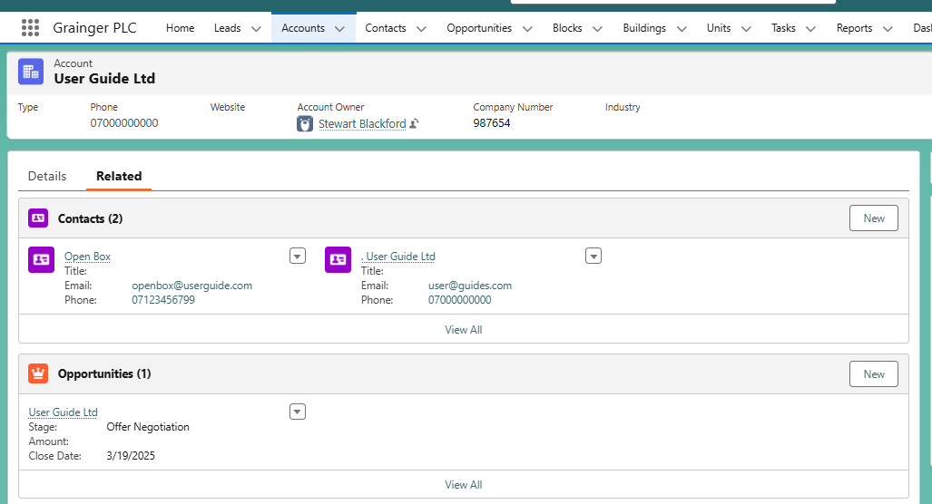
Note that a Contact has also been created called “. User Guide Ltd”.
Below is the newly created Opportunity. Along the top there is some key details, followed by a visual representation of the Commercial Leasing Journey, and then the remaining details.
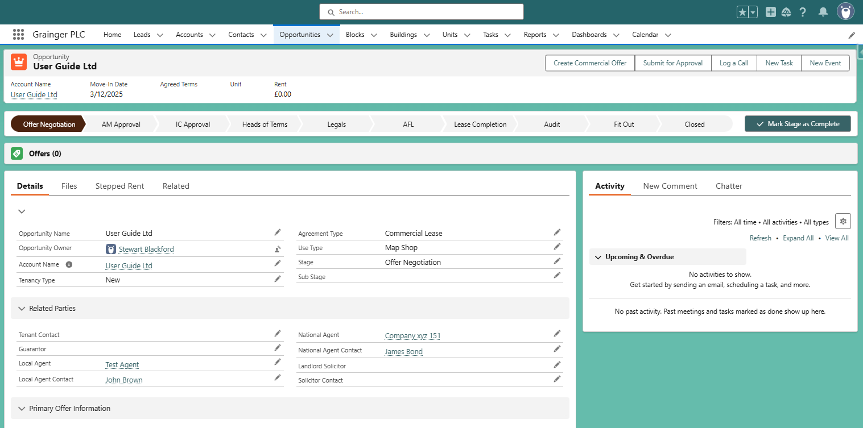

Create a Commercial Offer
To create a commercial offer, click on the Create Commercial Offer button. This will then open up a window to select a building.
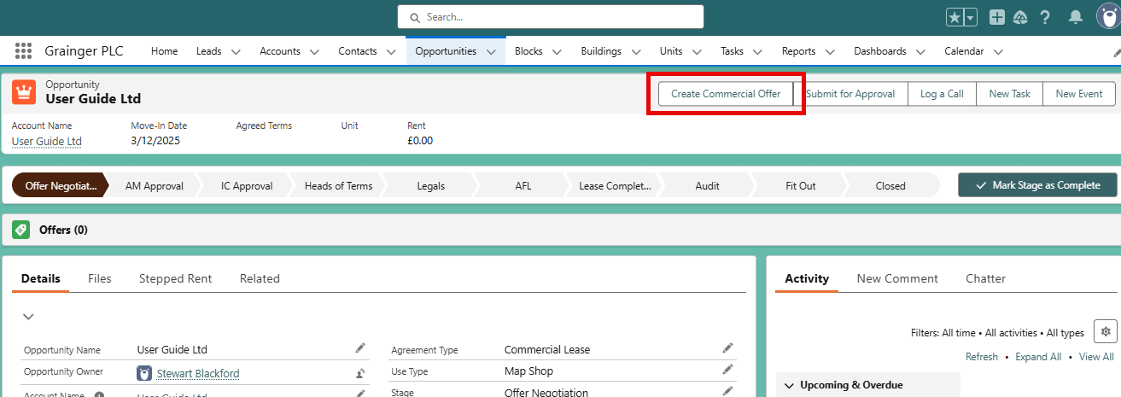
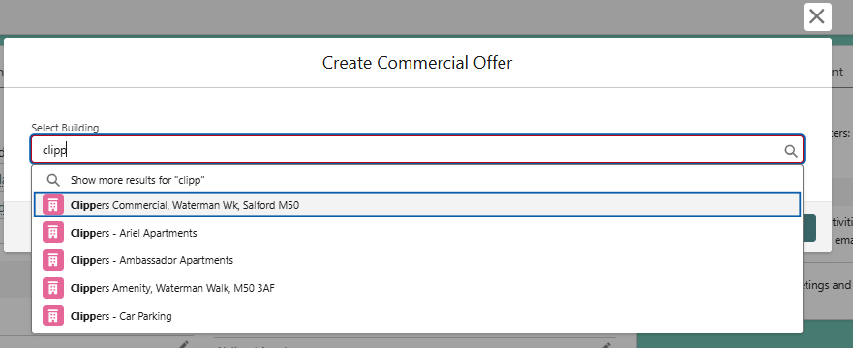
Selecting a building will then show units in that builidng that are ‘Commercial Unit’ record types. Selecting only one from the list will make that the ‘Primary Unit’. Selecting more than one will mean that one of those will need to be selected to be the ‘Primary Unit’.
The primary unit will be the unit that has all associated charges/payments etc. against it in Qube. Any other units will have ‘ghost opportunities’ so that the units are updated in Qube to be shown as let.
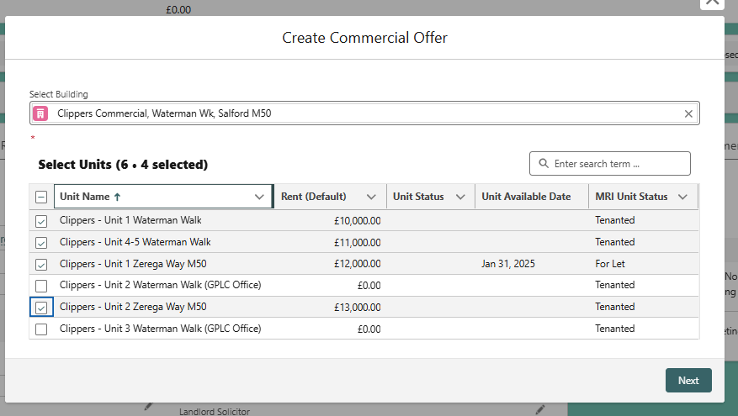
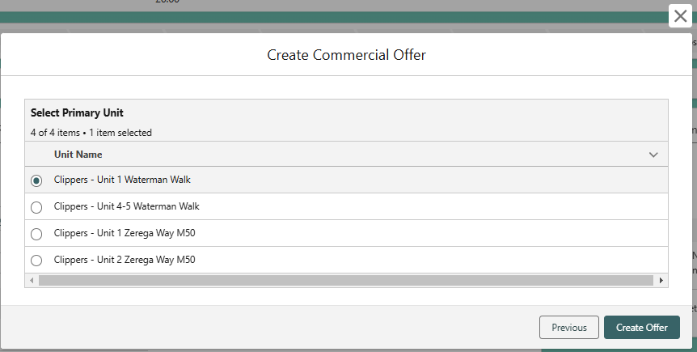
Click on Create Offer to create the offer. The page will refresh and now the Offer record will be displayed.
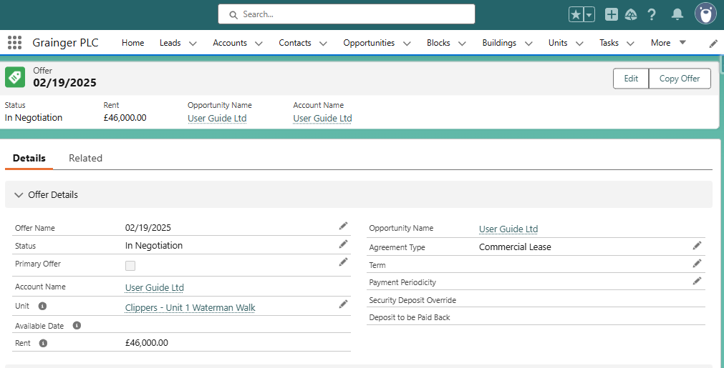
On this page, all the relevant details are to be included for the offer that was received. Details from this offer will be shown on the related opportunity.
Offer Details:
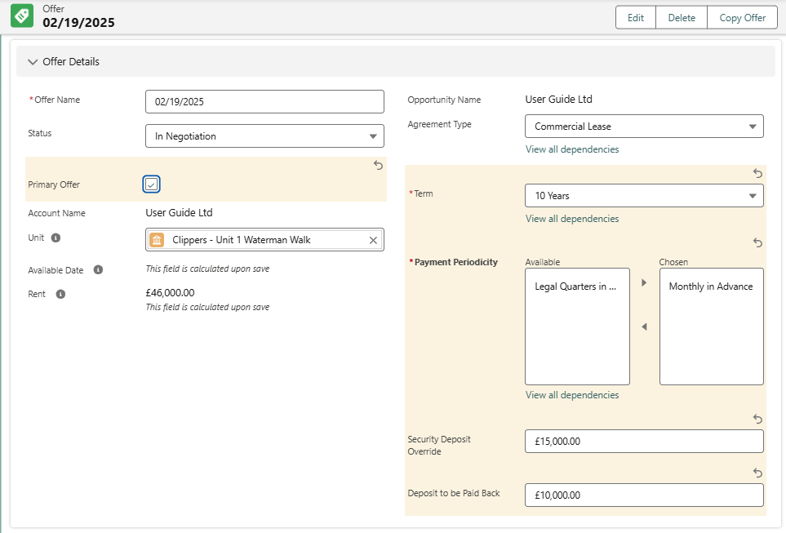
- Select the Term. This will then allow the user to add break clause information later
- Choose the Payment Periodicity
- Add in Depost information
  - Security Deposit Override – Input the amount for the deposit.
Tenant incentives:
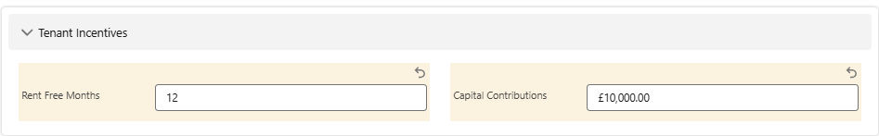
- Specify the number of Rent Free Months and the value of any Capital Contributions.
Break Clause Information:
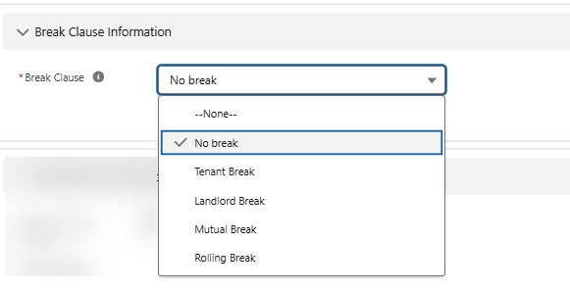
- Choose the type of Break Clause. If ‘No Break’ is selected, the following fields will not show on the page. Any other selection will make them visible.
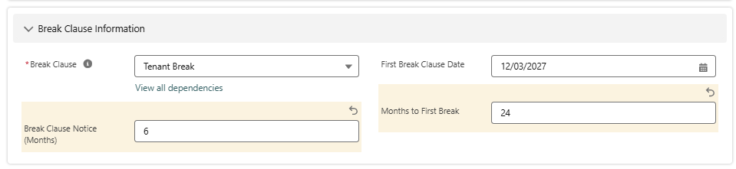
- Specify the Months To The First Break.
  - This will then calculate the First Break Clause Date based on the Move In Date. If the move in date changes on the Opportunity, or the Months to First Break is changed, the date will be updated here.
- Break Clause Notice Months: Specify the notice each party needs to serve to exercise the break.

After the intital offer has been created, the offer should be immediately copied. This is to ensure that the inital offer submitted is captured and any subsequent changes can be worked on this newly created one. This will also ensure that the Offer is marked as ‘Primary’

Update Offered Price
It is unlikely that an offer will always come in at the asking price. To change the price of the offer, the Offer Line Item needs to be updated. For an offer that has only one unit, there will be only one line item. If there are multiple units in the offer, there will be multiple line items.
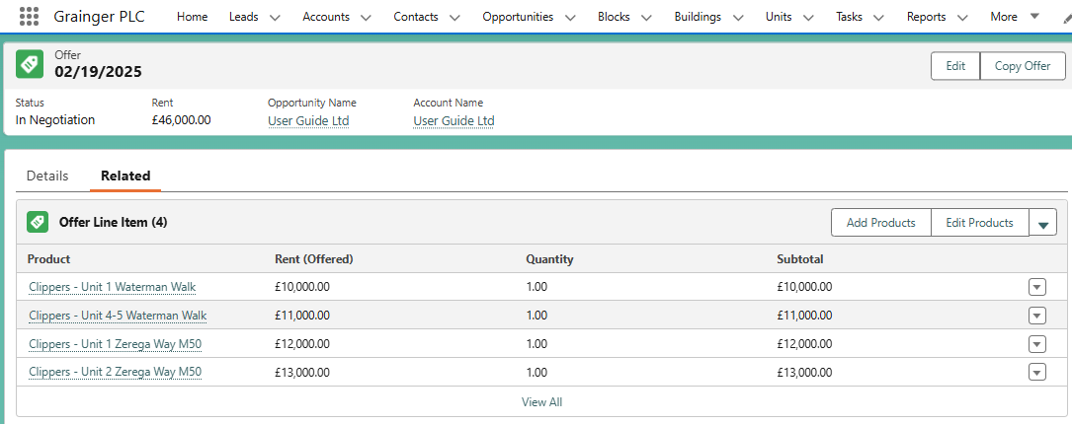
The Rent (Offered) price defaults to the Marketing Price. To edit the offer price, click on the button ‘Edit Products’.
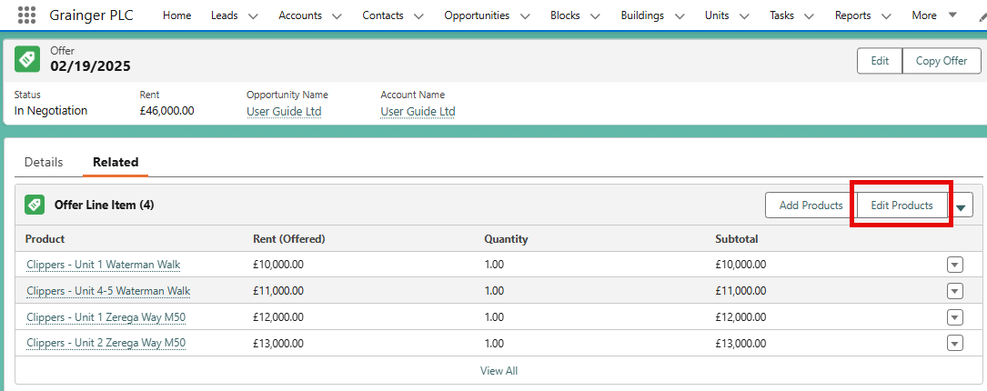
This opens up a page where all the offer prices can be changed. The Rent (Default) field is the Price Book Entry price, ie. the Marketing or Quote price for the unit. Changing the Rent (Offered) field will update the offer to the rent that the potential tenant has actually offered.
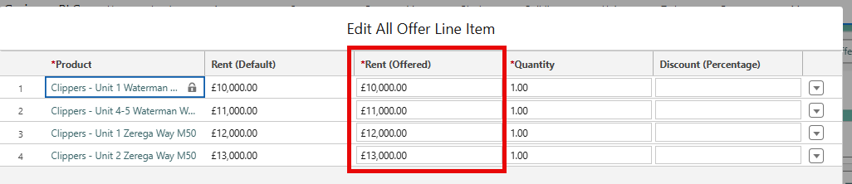
The Quantity field should never change – it should always remain as ‘1.00’.
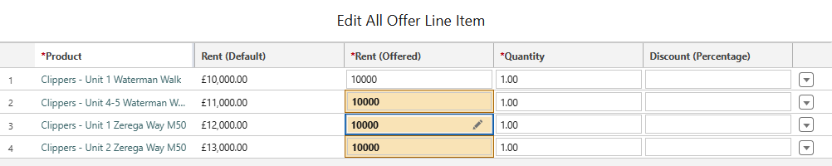
Clicking Save will update the prices. This change, along with changes to other key offer information, is tracked on the Offer History too. The Offer History is found on the Related Tab on the Offer.
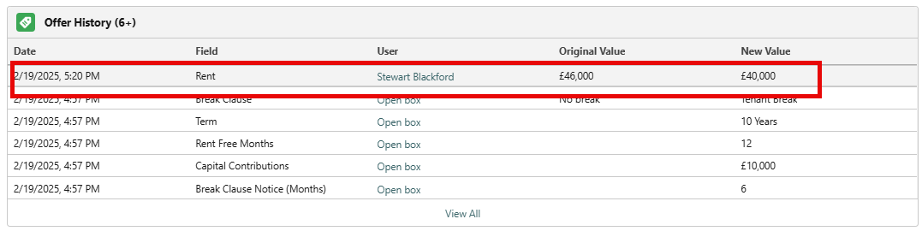

Copying an Offer
Throughout the negotiation process, if there are terms that are changing from the original offer, it is important to capture each new offer with the updated details. This can be done easily by copying a previous offer.
In order to copy a previous offer, it firstly needs to not be marked as the Primary Offer. Uncheck this field if needed, mark the Status as ‘Rejected’, and then save the record. Then, by clicking the Copy Offer button.
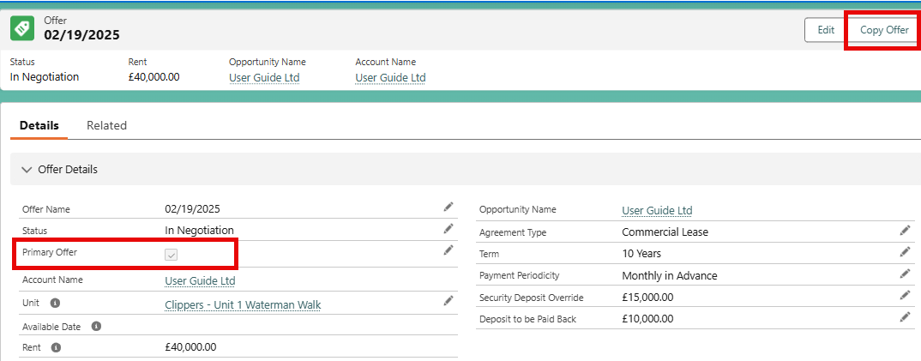
By clicking the Copy Offer button, a new offer will be created and marked as the Primary Offer. This new offer will be identical as the one before, so any changes can be made and there will be a full history of the negotiations. To make price changes follow 3.4 Update Offered Price, or make any other changes directly on the offer.
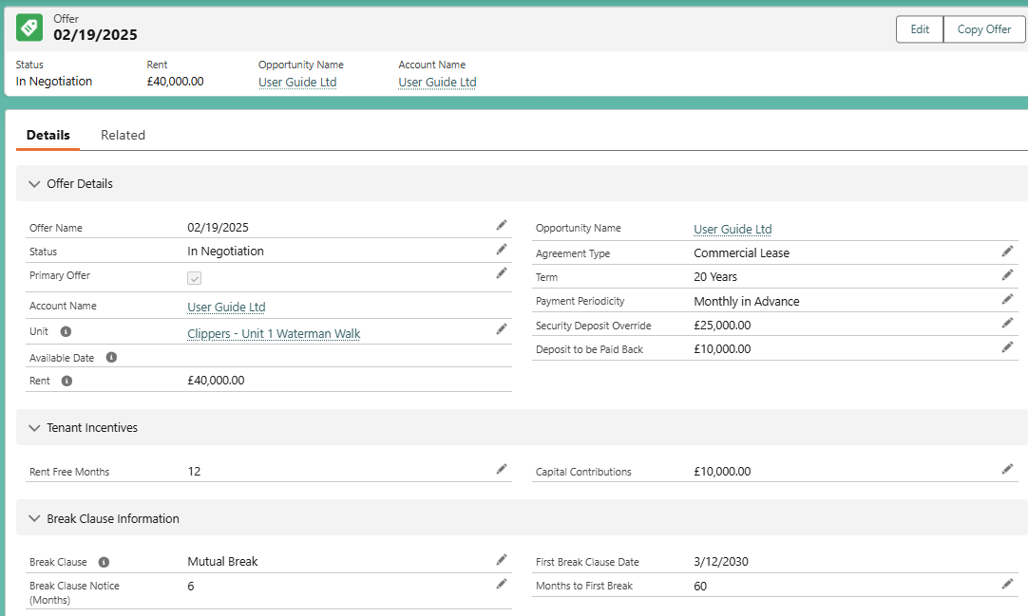
On the opportunity, all of the previous offers are also shown with some key information displayed to see the changes throughout the negotiaiton process.
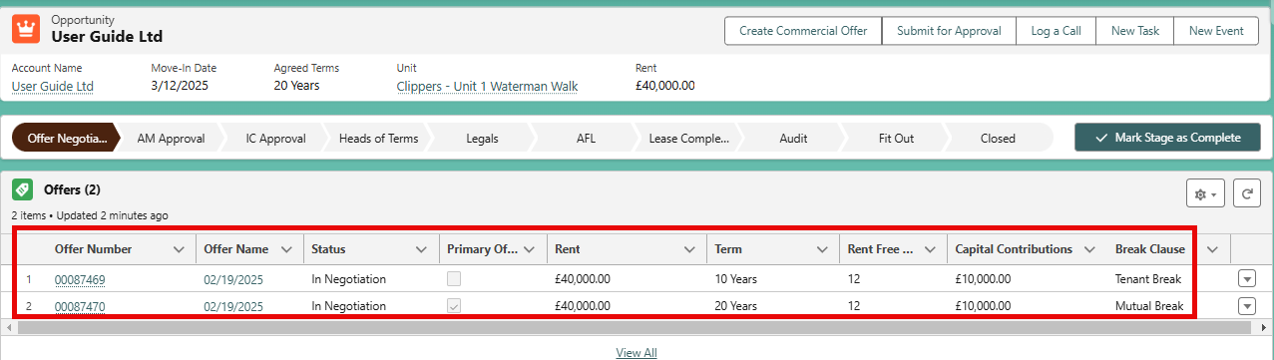

Asset Management and Investment Committee Approval

Asset Management Approval Process
Once an offer has been agreed to by the Commercial Lettings Team after the negotiations with the agent and/or tenant, the Asset Manager needs to approve. Clicking the Submit for Approval button will open a window where comments can be added for the Asset Manager.
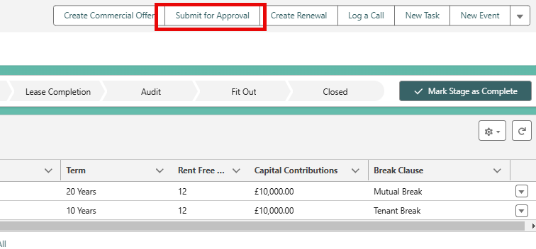
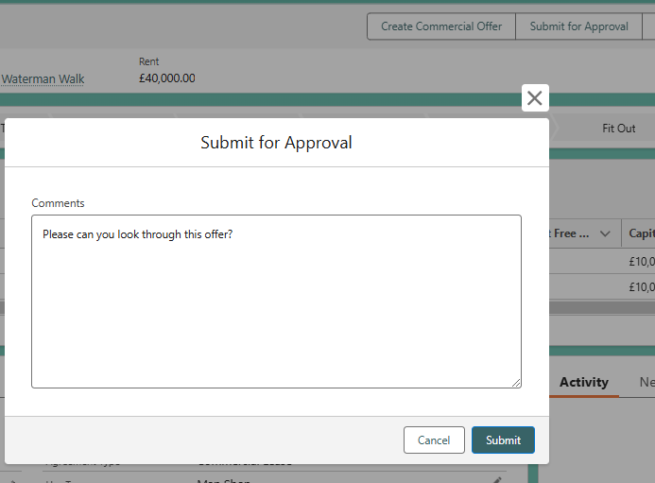

After clicking Submit, the opportunity will locked from further editing, will be moved to the AM Approval stage, and there will be a visible Approval History on the Related Tab
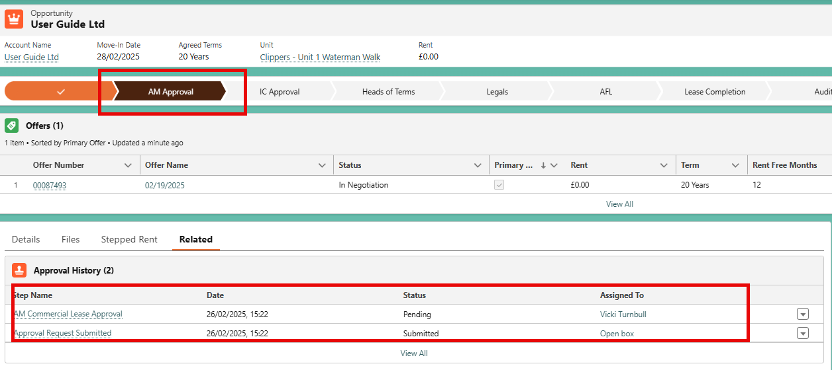
The Approval will be sent to the User that is listed as the Asset Manager on the Unit. If this field is empty, an approval will not be able to be raised. This field is one that is mastered in Qube, so any changes of Asset Managers should be completed there.
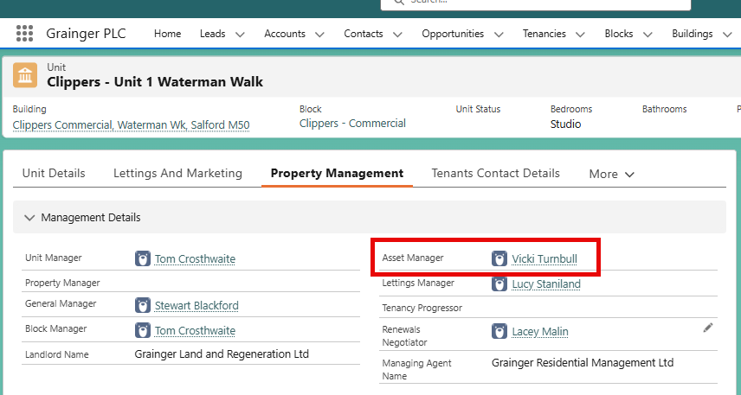
The Asset Manager will receive both an email and a Salesforce Notificaiton to prompt them to view the Approval Request.
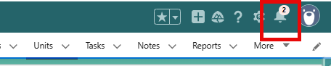
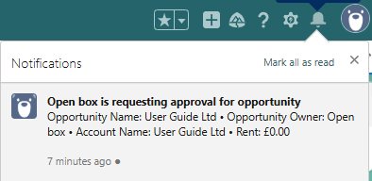
When the Asset Manager goes into the Approval Request, there will be some basic details shown. The Asset Manager can click on the hyperlinked Opportunity Name to open the Opportunity and view all the details before either Approving or Rejecting or Reassign the Approval Request.
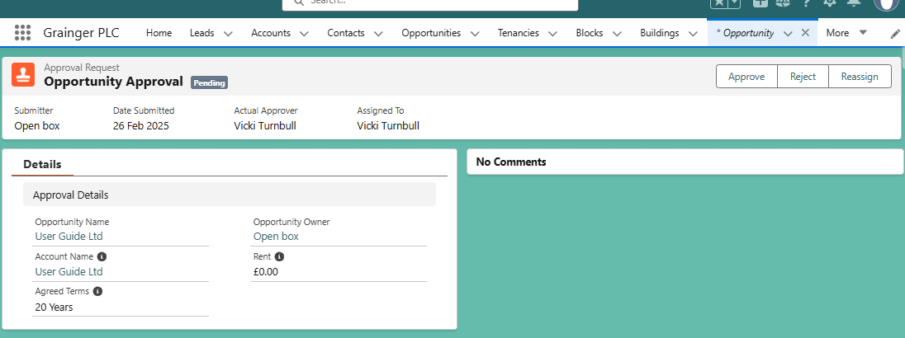
If the Approval Request is rejected, a comment must be entered.
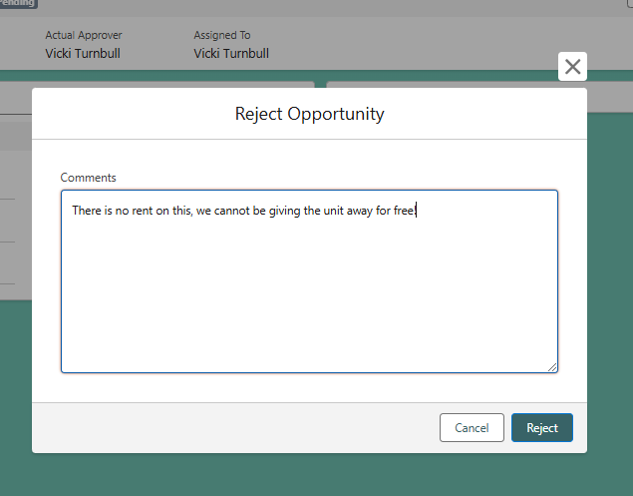
After the Rejection, the comment will be shown on the Approval Request. It will show that it has been rejected on both the Approval Request and on the Opportunity’s Approval History.
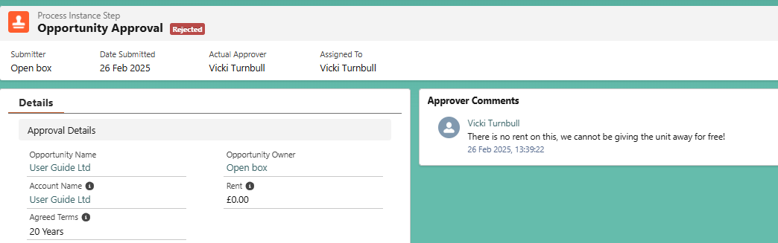
The Stage also moves back to In Negotiation, so that the Commercial Leasing Team can either make a new offer or close the opportunity if there is no further chance of improvements.
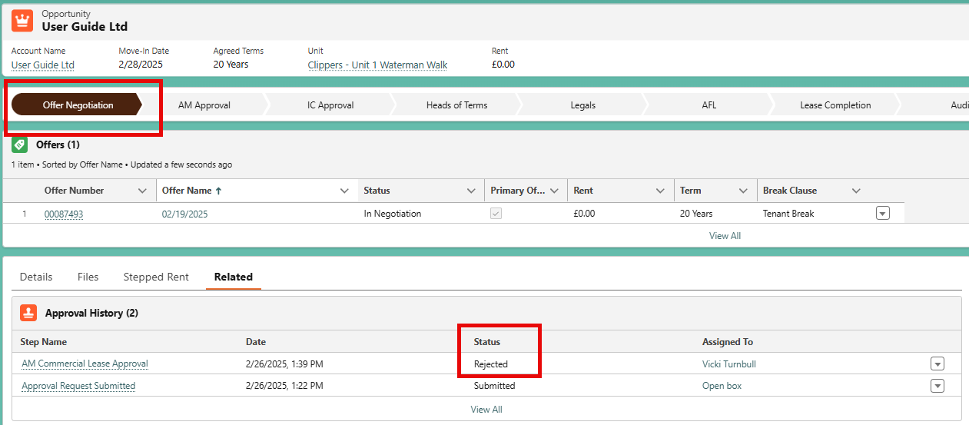

To submit again, follow the same process – all the different Approvals will be listed on the Related Tab for a full history. This time the Asset Manager wants to approve the Request. Again a comment should be added so there is a history.
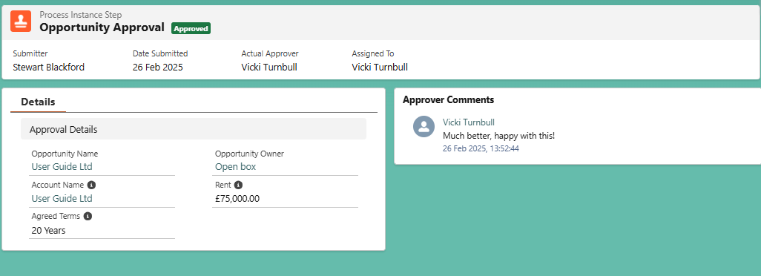
Again the related list on the Opportunity will reflect this approval and the stage will move on to IC Approval stage automatically.
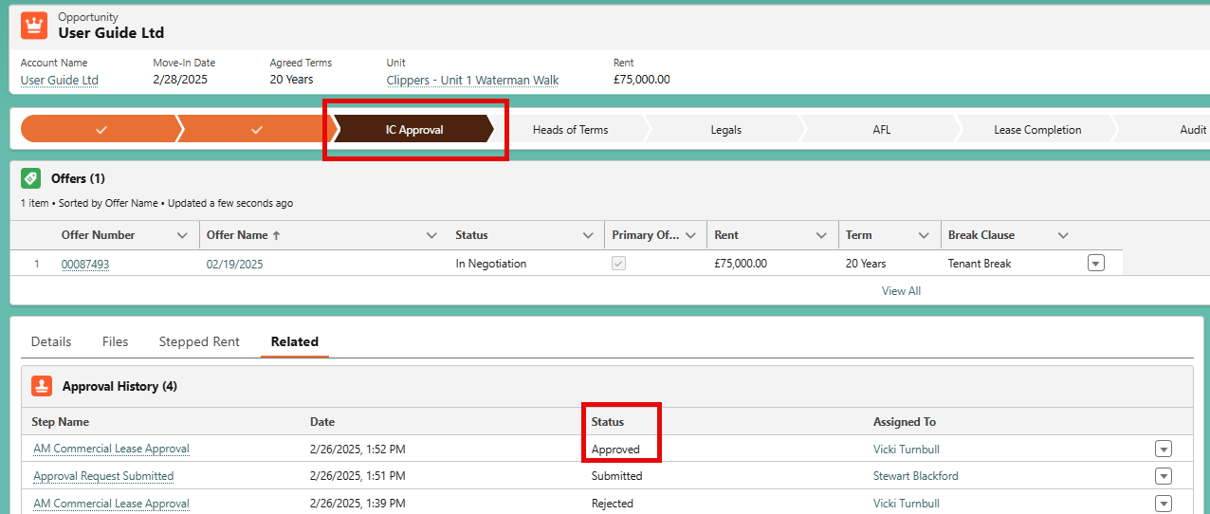
Further to this, the date as well as the AM comments are saved to the opportunity under the Approval Section. Once the IC Approval has been obtained, and the stage marked as complete, the IC Sign Off Date will also be stamped with the completion date.
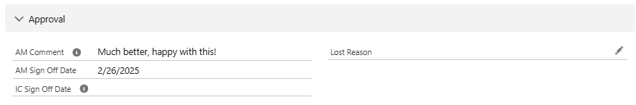

Progressing or Closing the Commercial Opportunity
After the IC has approved the offer, the opportunity can now be progressed throughout the rest of the commercial leasing journey.

Capturing Comments & Delays
Progressing through the process, further information can be captured directly on the opportunity. This could include notes for delays and comments
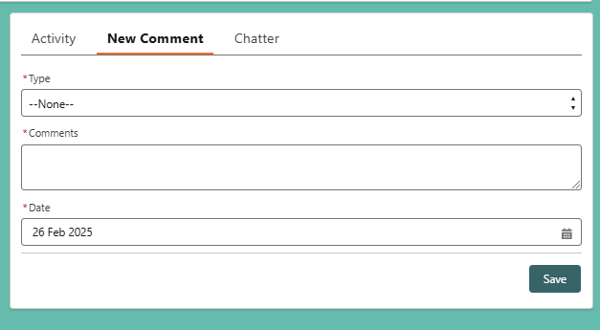
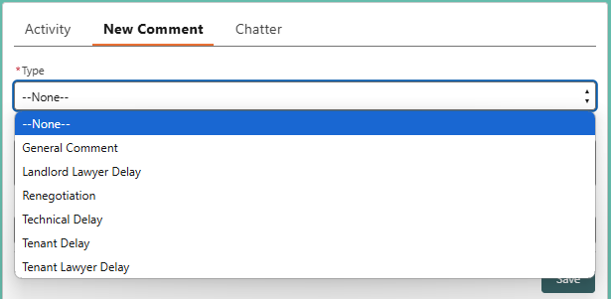
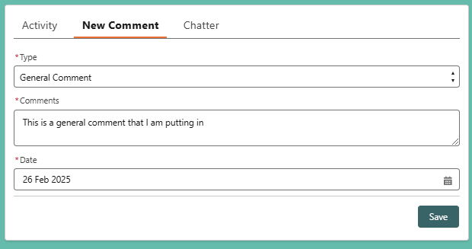
Clicking Save will add this to the Activity Timeline and show all comments/updates that have occurred on the Opportunity.
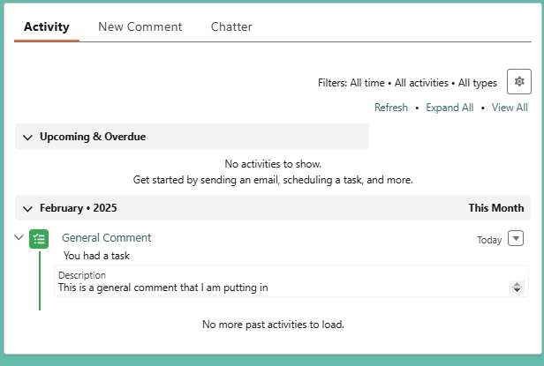

Closing a Rejected Opportunity
If the Asset Manager or the IC reject the offer, and it cannot be improved, or Grainger do not want to continue, the Opportunity can be closed. To close an Opportunity, select the Closed stage on the path and click Select Closed Stage.
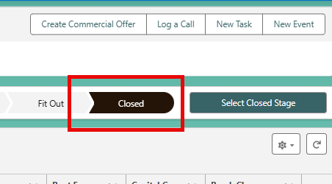
This will open a window where more details can be captured. Make sure to change the Stage to Close Lost, and provide both a Lost Reason and indicate the team that rejected the offer in Sub Stage.
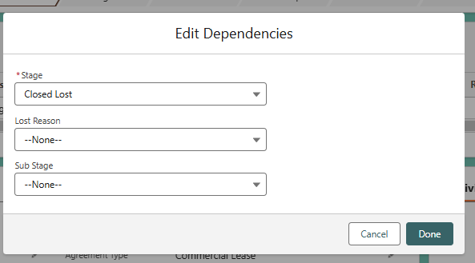
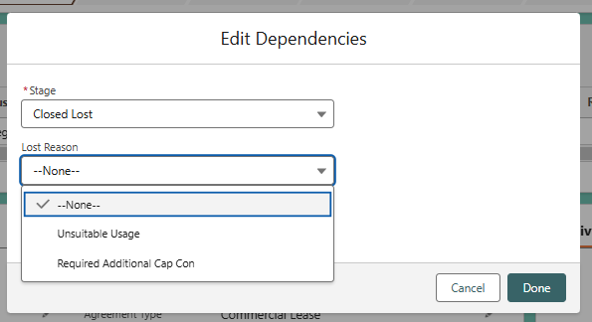
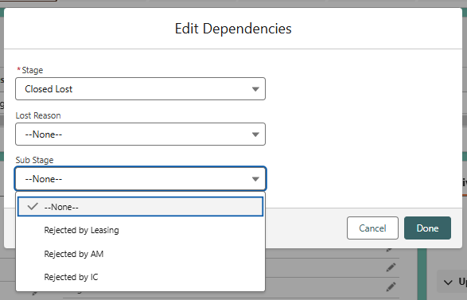

Initial Integration to Qube
The Commercial Opportunity will be integrated to Qube initially when the Deposit Paid / Create Future Tenancy checkbox is marked as true. When this is ticked, any Shadow Opportunities will be created for the additional units in the offer, dummy tenants will be created in Qube.

Once the checkbox is marked as true, it is not possible to uncheck it, as the details have already passed to Qube. As for the Shadow Opportunities, users will not see these anywhere and are only used in the background to ensure that all units in Qube are updated as required.

